Nama : Riccardo Davinci

NIM : 2602089811

Jurusan : Computer Science

Kampus : Kemanggisan

**SpaceTD**

**SpaceTD** is a private Indonesian aerospace manufacturer and space transportation services company founded in 2002. The company's mission is to reduce space transportation costs and enable the colonization of Mars. SpaceTD designs, manufactures, and launches advanced rockets and spacecraft, with the goal of creating reusable launch vehicles that can be used for multiple missions. Some of SpaceTD's notable achievements include the first privately funded liquid-propellant rocket to reach orbit (Falcon 1 in 2008), the first privately-funded company to successfully launch, orbit, and recover a spacecraft (Dragon in 2010), and the first privately-funded company to send a spacecraft to the International Space Station (Dragon in 2012).

SpaceTD is currently planning to create a website for their service, so they can reach more people from all around the world. First, SpaceTD needs to create a **website prototype** and company website that represents the SpaceTD image. With this website, SpaceTD hopes to improve service to its customers. SpaceTD entrusts you as a web designer to design their website prototype and create a company website.

The **requirements** from SpaceTD are described below:

1. SpaceTD wants you to design the **website prototype** of all **five pages** before making the HTML files. The website prototype will be created using **Figma**. Ensure the website prototype that you created is the **exact same** as the website that you will make later. Each page will contain **header**, **navigation**, **content**, and **footer** as its structure. Consider the **color**, **layout**, and **consistency** when designing the prototype.
   * 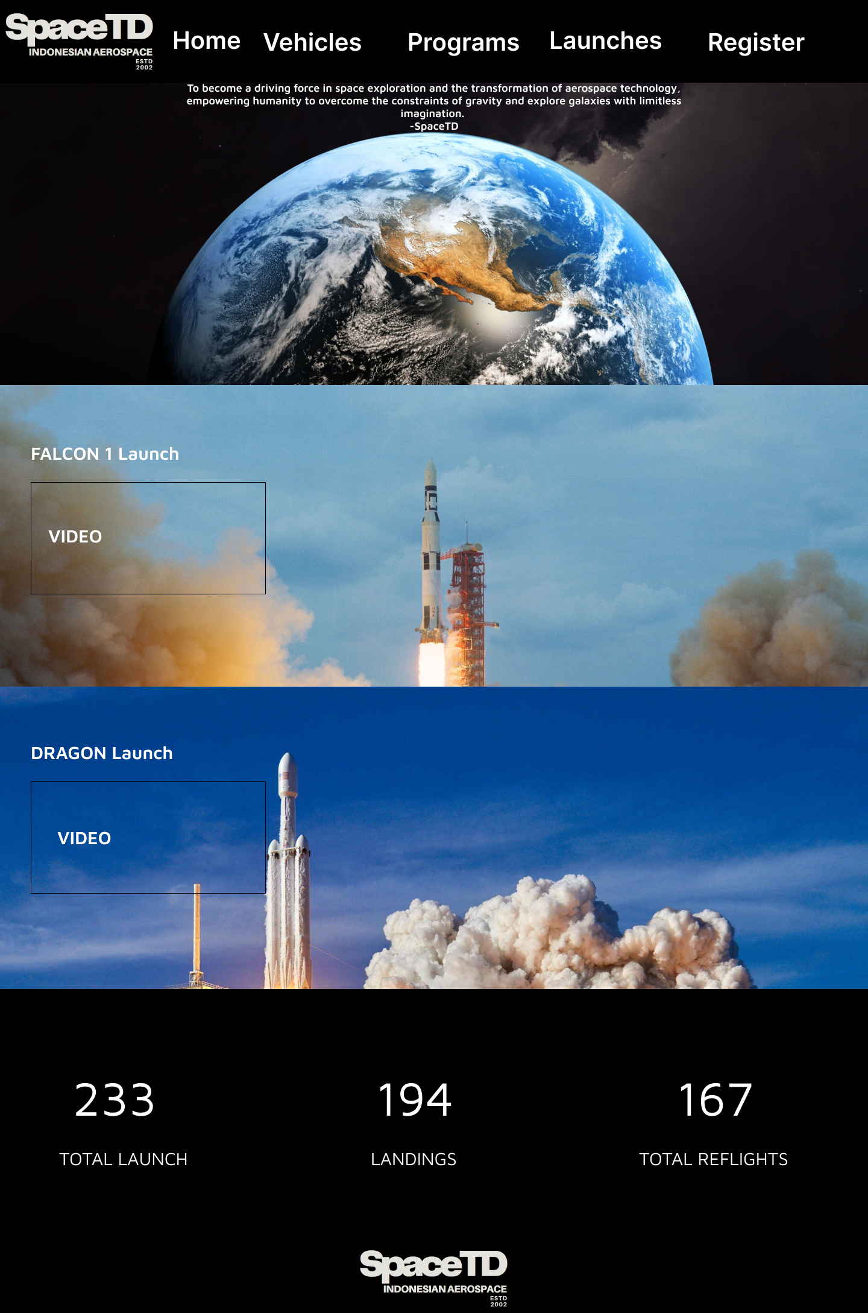Home Page
   * 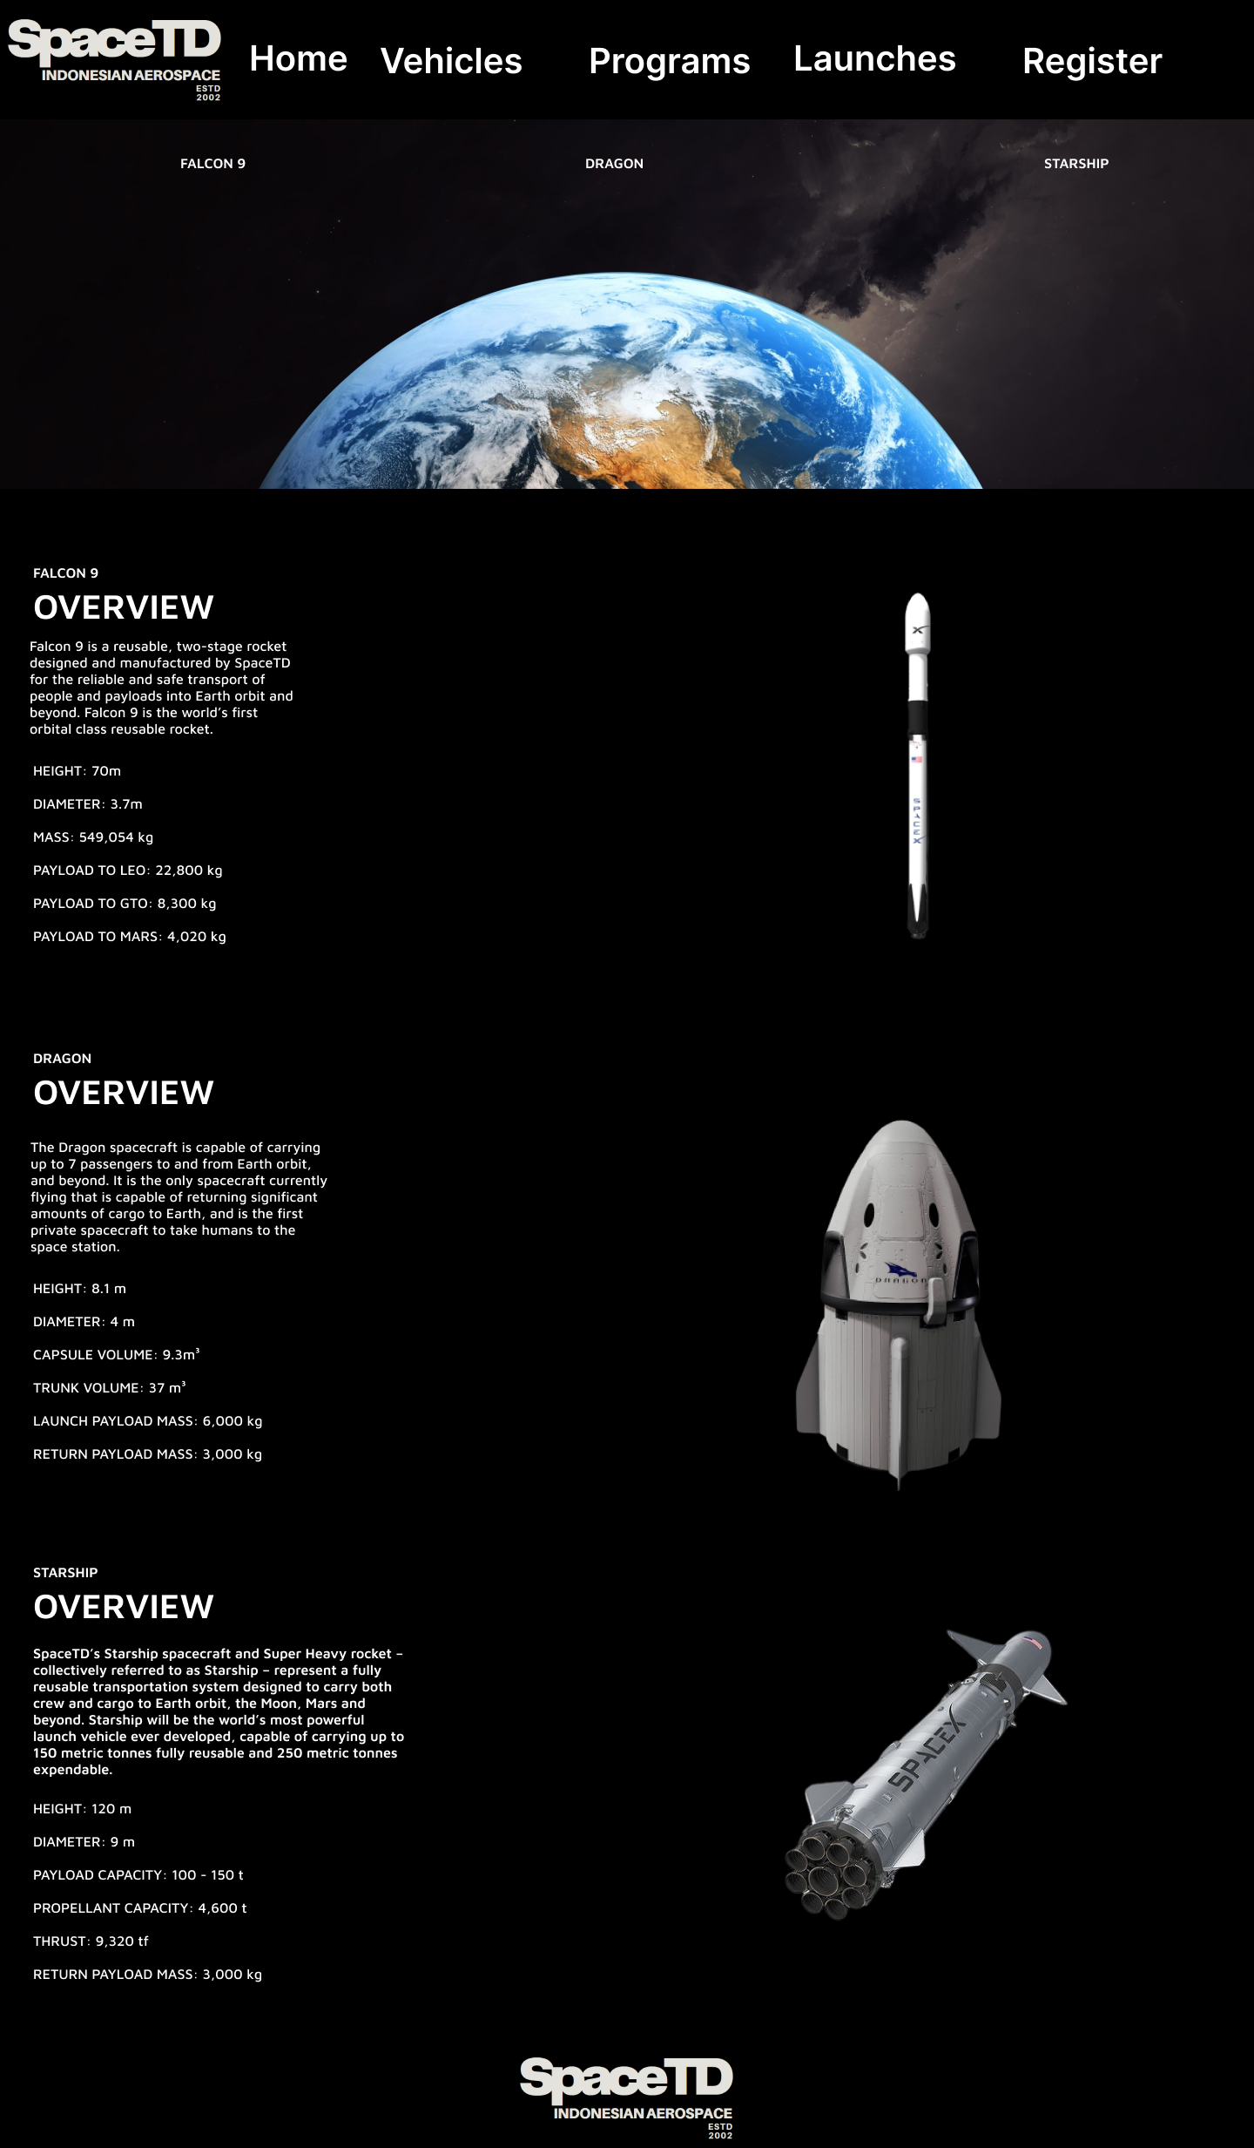Vehicles Page
   * 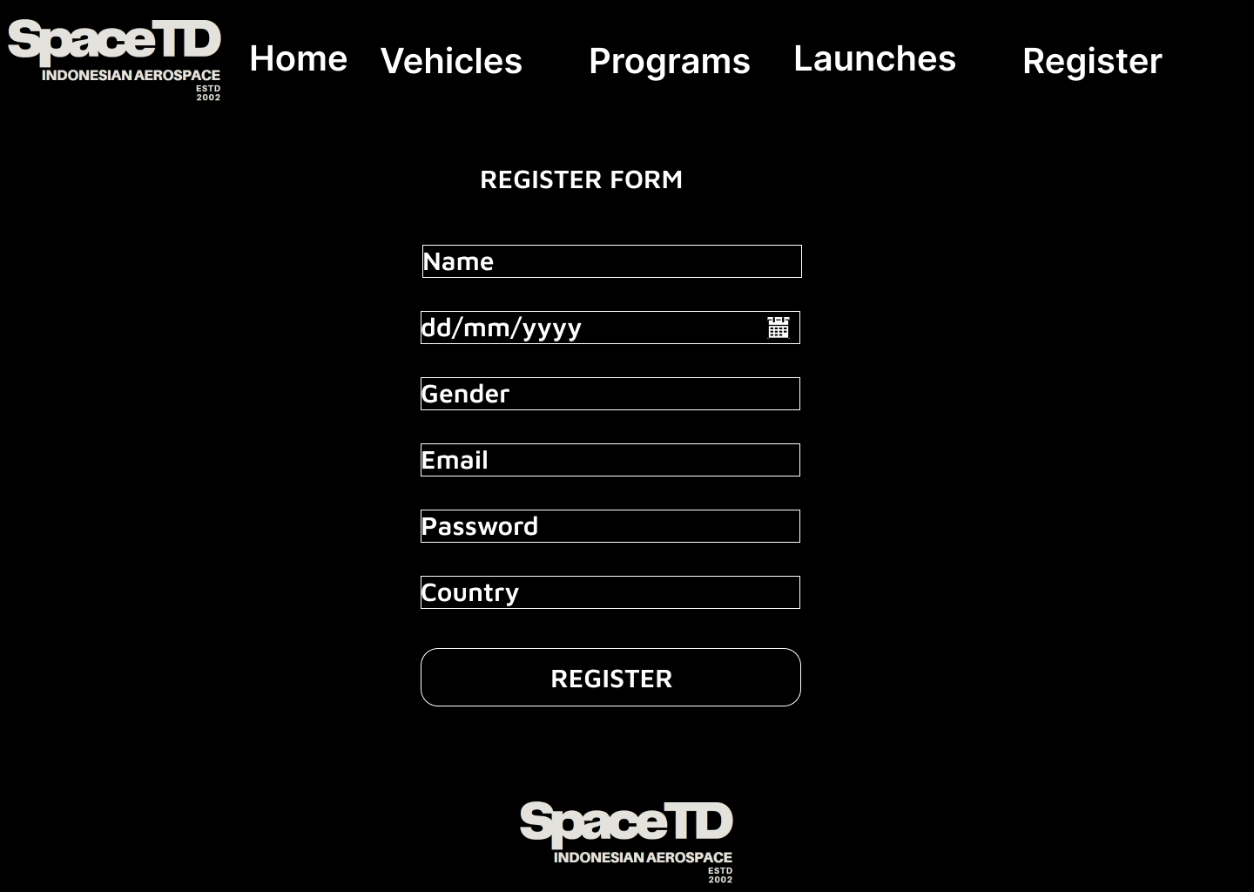Register Page
   * 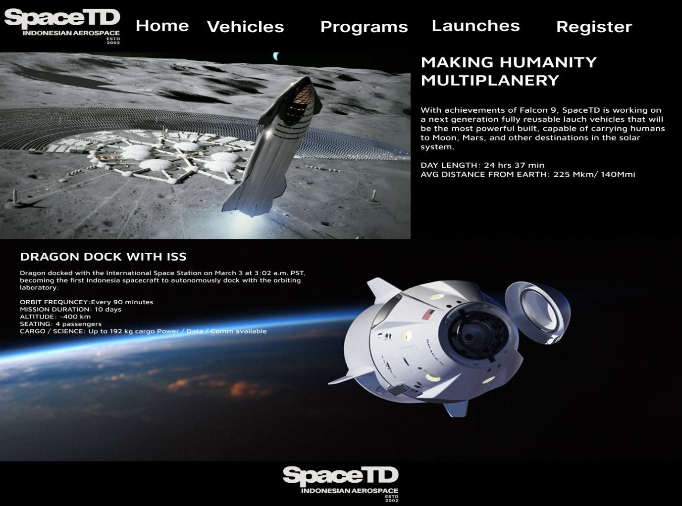Program Page
   * 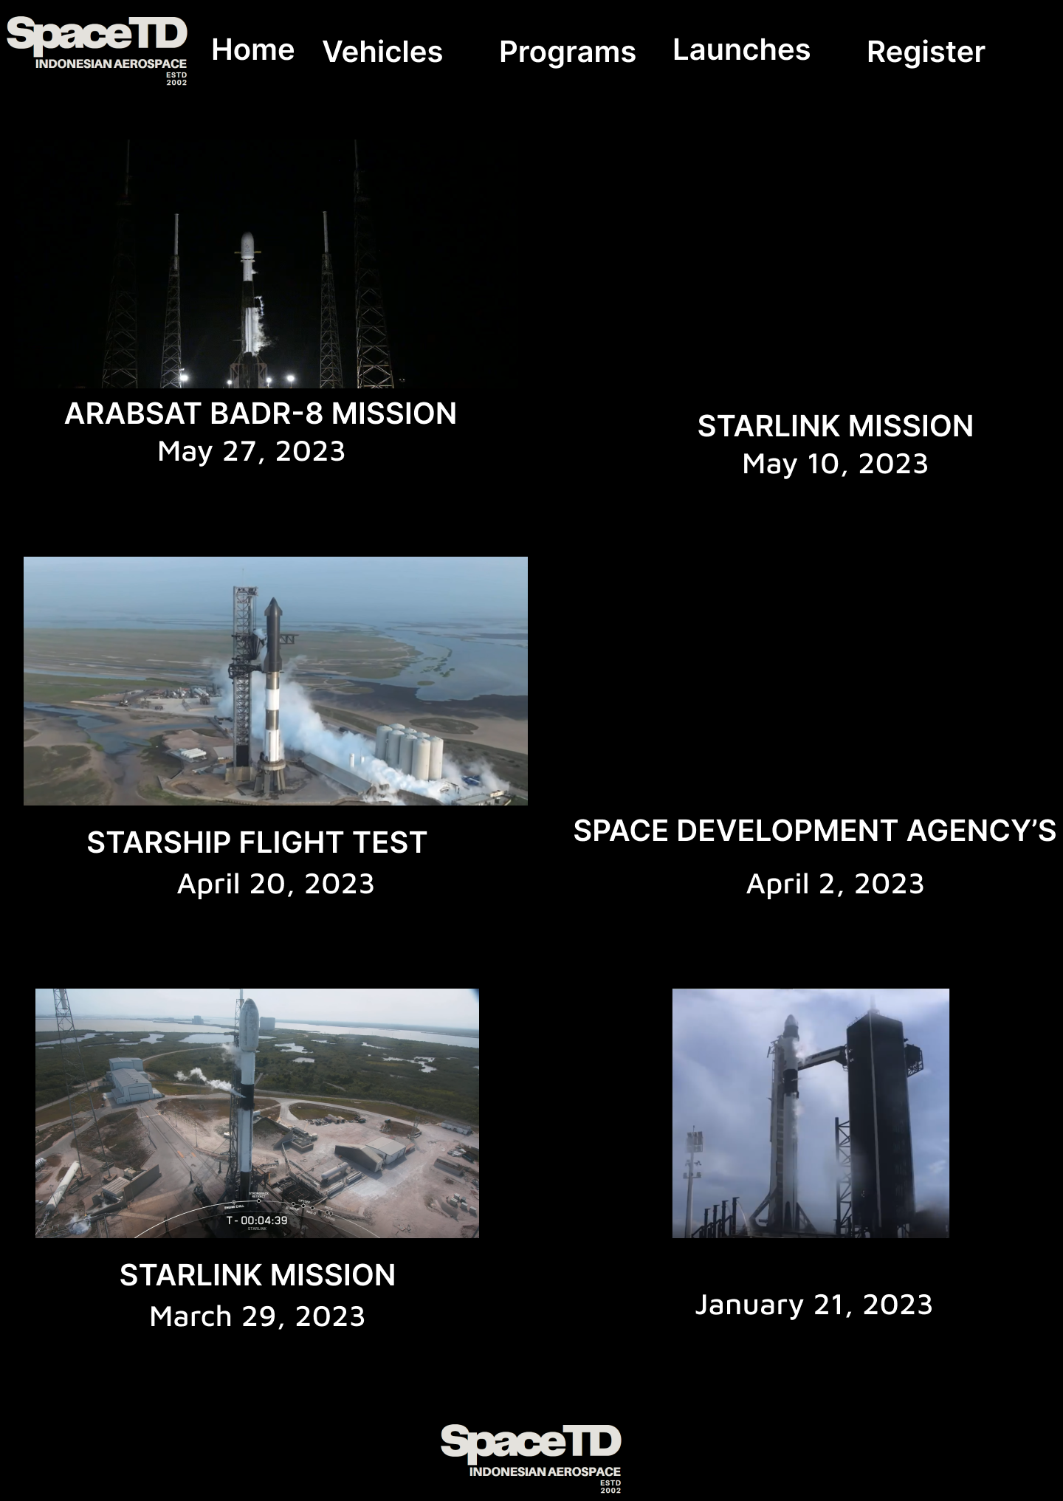Launches Page

Link:

1. SpaceTD_Website Prototype:  
   <https://www.figma.com/file/muI7WKnCgXQU5fHBgoXEWS/2602089811-RiccardoDavinci-LABHCIQuiz?type=design&node-id=65%3A54&t=6Uhd7oPNiFpATfnc-1>
2. Assets
   1. <https://www.canva.com/design/DAFj2PpqsC4/CNG6TQtqF1S7wdiCweZ0VQ/edit?utm_content=DAFj2PpqsC4&utm_campaign=designshare&utm_medium=link2&utm_source=sharebutton>: SpaceTD logo
   2. https://wallpapercave.com/w/wp4568894: earth wallpaper
   3. https://wallpapercave.com/w/wp6503939: dragon bc
   4. https://wallpapercave.com/w/wp8807070: falcon 1 bc
   5. https://uxwing.com/date-icon: date icon
   6. <https://sketchfab.com/3d-mo> dels/falcon-9-spacex-394f7cf52d124bbd9db69f24d1ff2f08: falcon9model
   7. https://www.youtube.com/watch?v=dLQ2tZEH6G0: faclon 1 launch
   8. https://sketchfab.com/3d-models/spacex-crew-dragon-b4189c6d1dad404a8ea25cad042161c1: dragonview
   9. https://www.cgtrader.com/3d-models/space/spaceship/spacex-starship-heavy: starshipview
   10. https://www.behance.net/gallery/77029515/SpaceX-Crew-Dragon-%284K-Wallpaper-FREE%29: dragondockiss
   11. https://www.youtube.com/watch?v=1gmvUPTdoP4: dragonlaunchvid
   12. https://www.youtube.com/watch?v=lBJ9uWdCLRI: ARABSAT BADR-8 Mission
   13. https://www.youtube.com/watch?v=bzAcO60OPrk: starlink mission 11 may
   14. https://www.youtube.com/watch?v=vnnUoZ66ihg&t=5s: Space Development Agency’s Tranche 0 Mission
   15. https://www.youtube.com/watch?v=-1wcilQ58hI: starship flight test
   16. https://www.youtube.com/watch?v=EfJxpU0CLNI: starlink mission
3. Reference  
   SpaceX: <https://www.spacex.com/>
4. SpaceTD wants you to build the **website attractive**, **appealing**, **fully functional**, and make sure the website is **responsive**. The website should be accessible using a mobile phone in a perfect way. To achieve that, use **5 kinds of CSS property** and **JavaScript**. Use **meta viewport tag** and **media screen rule** that will be applied if the screen is **below 768px screen width**.
5. The website consists of **five main pages**. They are **Home Page**, **Vehicles Page**, **Register Page**, **Programs Page**, and **Launches Page**. Below are the requirements for each page:
   * **Home Page**

This page shows SpaceTD’s **rocket launch video**, SpaceTD in numbers including **number of successful launches**, **landings**, **and reflights**. This page also shows SpaceTD’s **vision**.

* + **Vehicles Page**

This page shows all **list of SpaceTD’s space transportation**. Make sure to provide the **name, overview** (such as height, diameter, weight, etc.), and **image** **of the transportation** so people can get better insight about the transportation.

* + **Register Page**

This page provides a register form for the people who want to travel to space. SpaceTD needs a person’s **personal information**, such as **full name**, **gender**, **email**, **date of birth**, **password**, and **country**. You are asked to create **five kinds of form components** and **five kinds of validation**. For validation, you must create it using **JavaScript** and **don’t use regular expression**.

* + **Programs Page**

This page shows **all SpaceTD’s space travel programs**. Make sure to provide **name**, **description**, **flight** **duration**, and **image**.

* + **Launches Page**

This page shows **recent SpaceTD’s space mission**. Make sure to provide **launch date**, **mission** **name**, and **rocket launch image**.

Website Page

* Home Page
  + 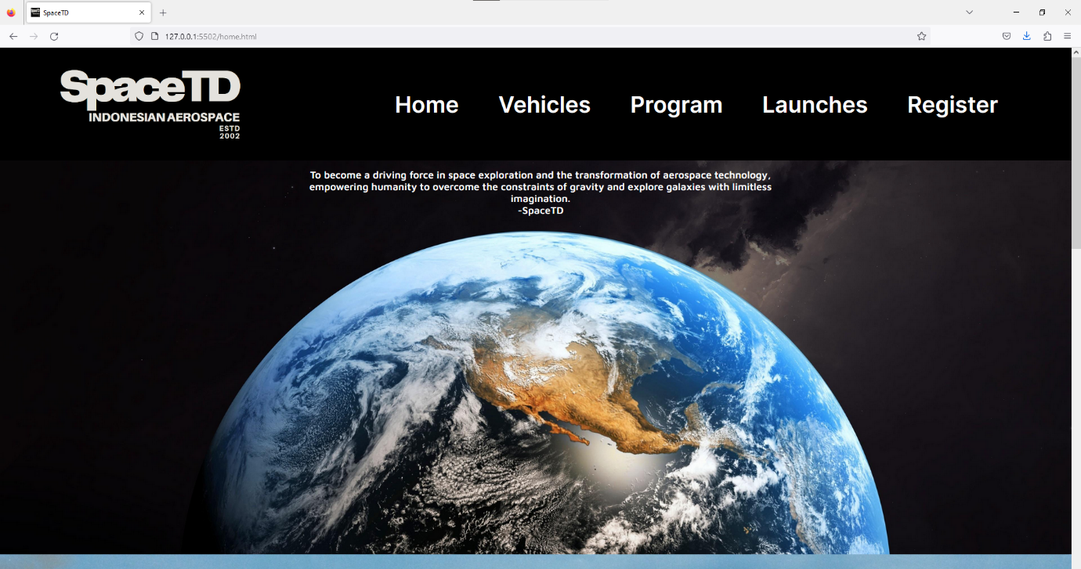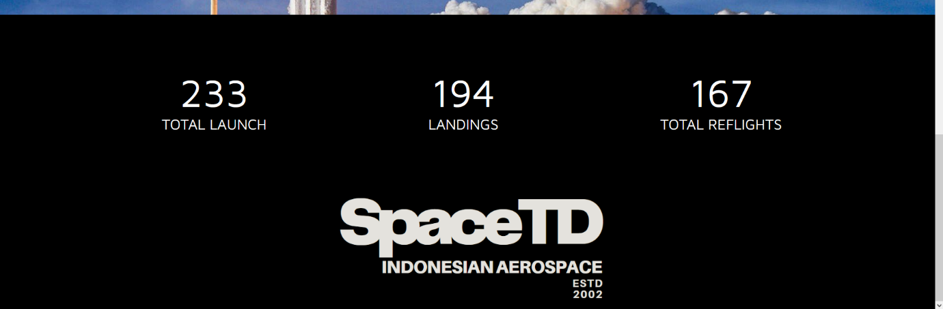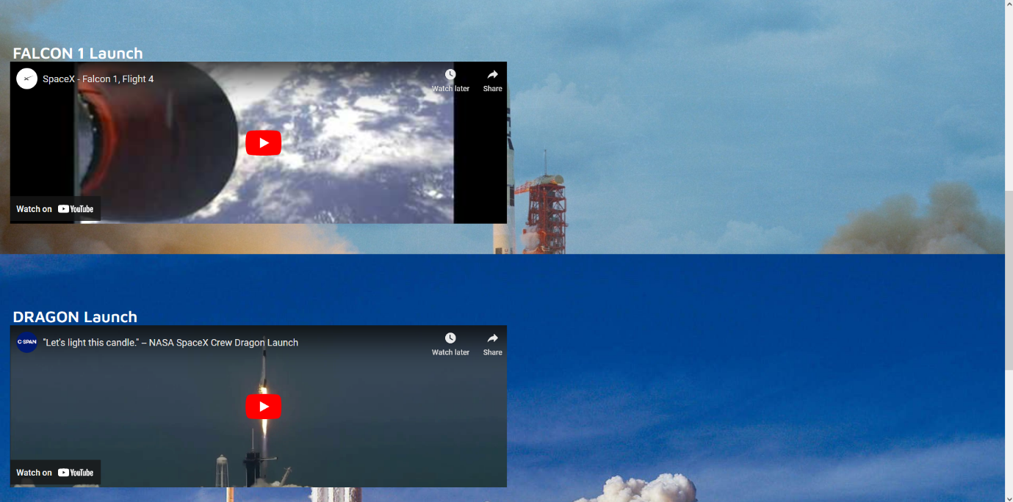Desktop View  
    The Head of this page show The SpaceTD logo and page title ‘SpaceTD’. This page uses black background that covers every content in home page. Navigation bar consist of SpaceTD logo and Navigation links to the Home Page, Vehicles Page, Register Page, Program Page, Launches Page. The body of this page shows SpaceTD vision with earth background, below of our vision shows video of falcon 1 launch and Dragon launch. The launch video embedded from YouTube with player controls. The last content in body is info of total launch, landings, total reflights  
    The footer of this page has a black color background and show SpaceTD logo in the center.
  + Tablet View  
    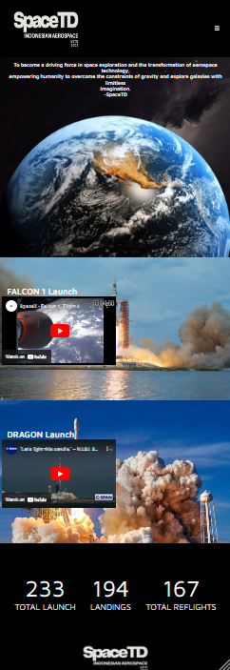  
    In the tablet view, the content of the page is same as in desktop view. The difference only in navigation bar. Navigation bar shrink into SpaceTD logo and a navigation toggle button that will change into close mark button and show the navigation dropdown menu. When clicked the close mark button will close the navigation dropdown menu.
  + Mobile view  
    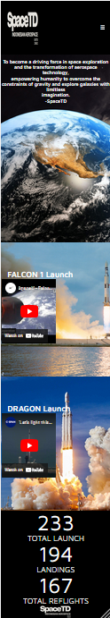  
    The mobile phone view also same as the tablet view. The only difference is the content of this page shrink even smaller. The page contents will also flex down due to the smaller screen size
* Vehicles Page
  + 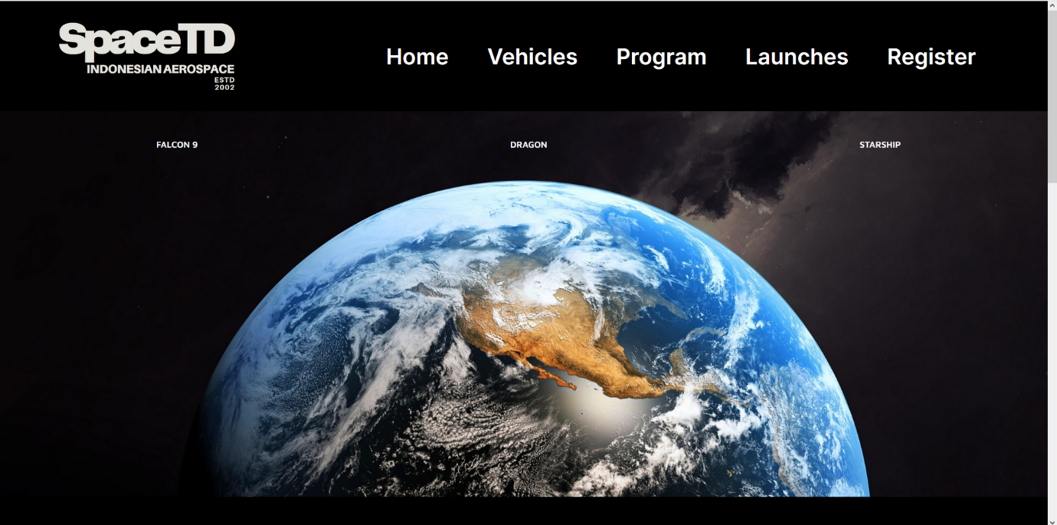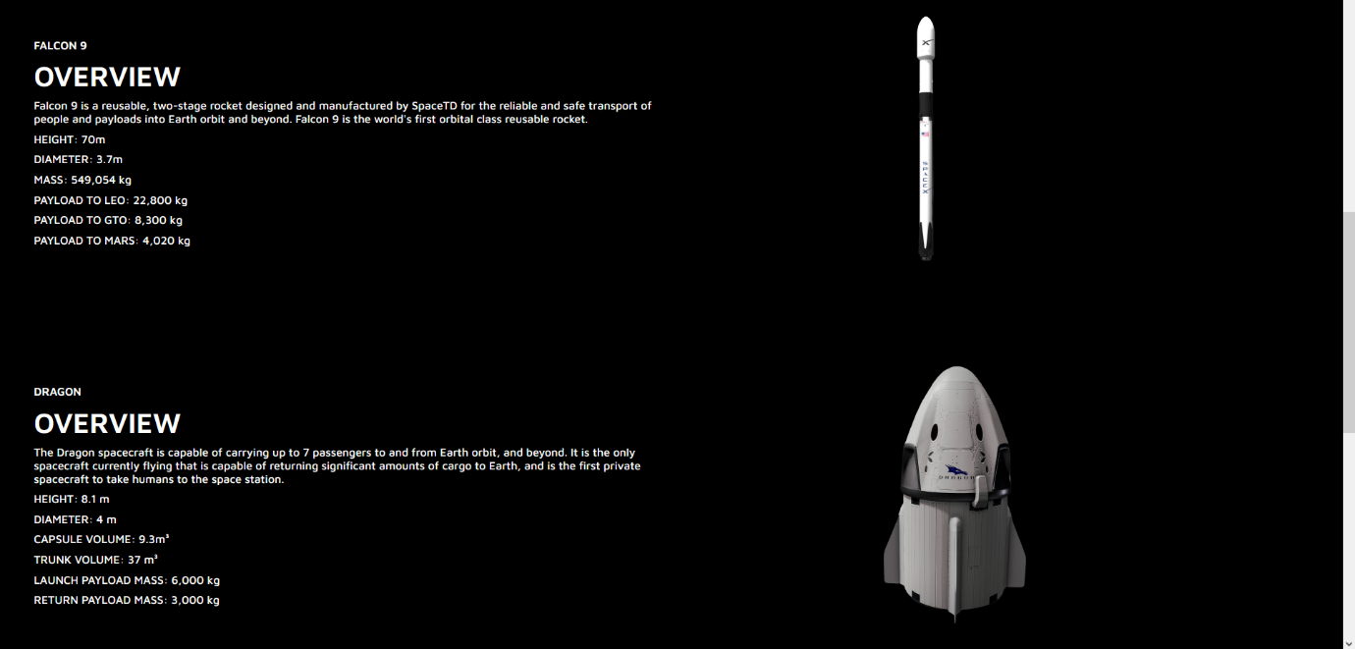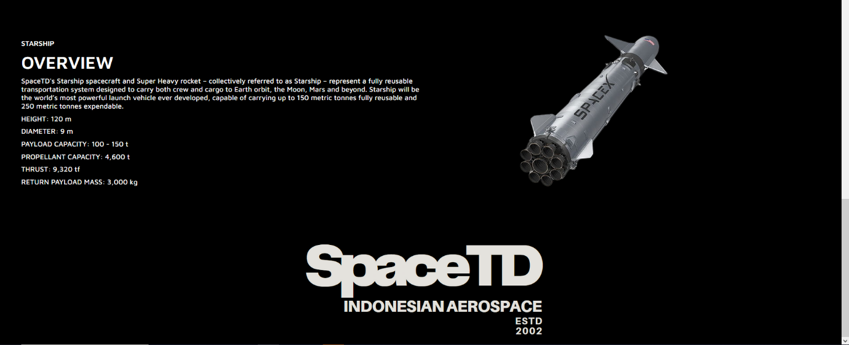Desktop View  
      
    The head of this page shows SpaceTD Logo and title ‘SpaceTD-Vehicles’. This page also same as home page, uses black color as a background. Navigation bar also same as home page navigation bar. The body of this page shows list of SpaceTD vehicles with earth background. When clicked on vehicles list will navigate to the overview of the vehicles and image vehicles. The footer of this page same as in the home page.
  + 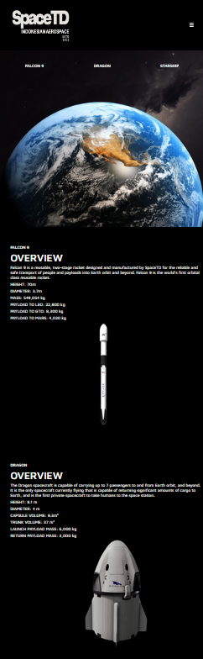Tablet View  
      
      
      
      
      
      
      
      
      
      
      
      
      
      
      
      
      
      
      
      
      
      
      
      
      
      
      
      
      
      
      
      
      
      
      
      
      
      
      
      
      
      
      
      
      
      
      
      
      
      
      
      
      
    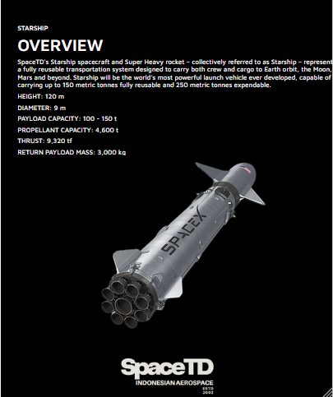  
      
      
      
      
      
      
      
      
      
      
      
      
      
      
      
      
      
      
      
      
      
      
      
      
      
      
      
      
      
      
      
      
      
      
      
    In the tablet view, the contents of the page are the same as in the desktop view. The difference are the same as in the tablet view of the home page.
  + 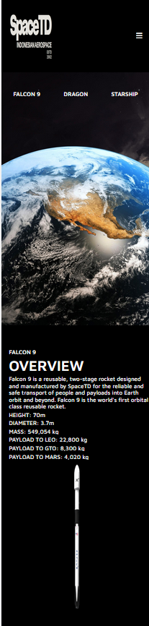Mobile phone view  
      
      
      
      
      
      
      
      
      
      
      
      
      
      
      
      
      
      
      
      
      
      
      
      
      
      
      
      
      
      
      
      
      
    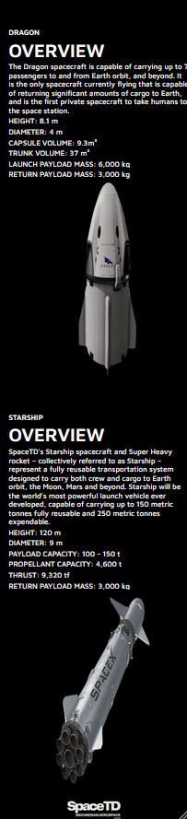  
      
      
      
      
      
      
      
      
      
      
      
      
      
      
      
      
      
      
      
      
      
      
      
      
      
      
      
      
      
      
      
      
    The mobile phone view same as the tablet view. The difference also same as mobile phone view home page.
* Register Page
  + 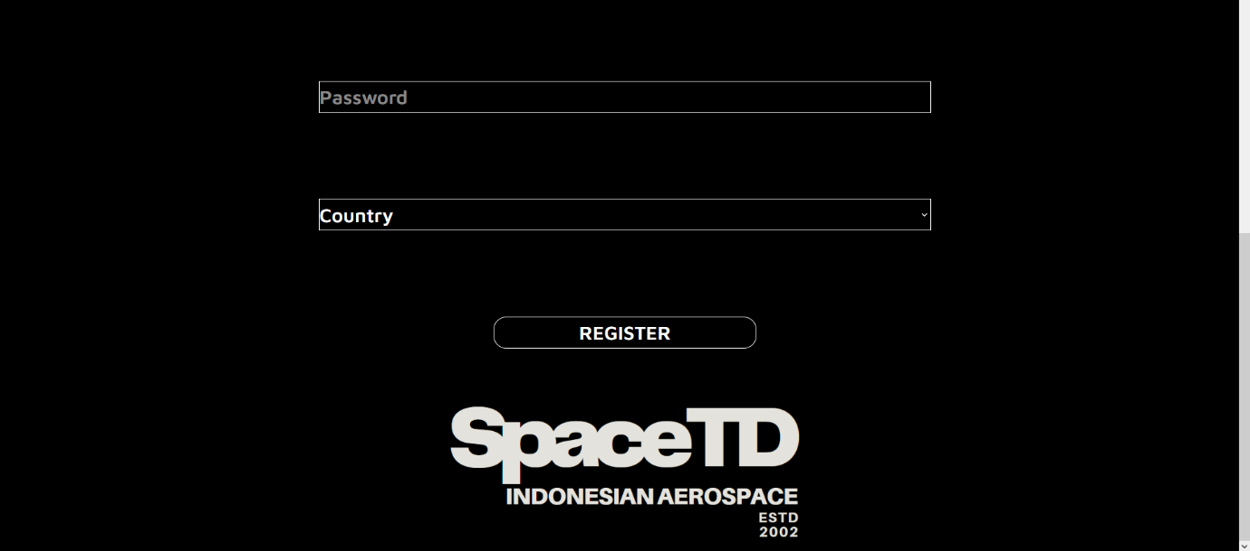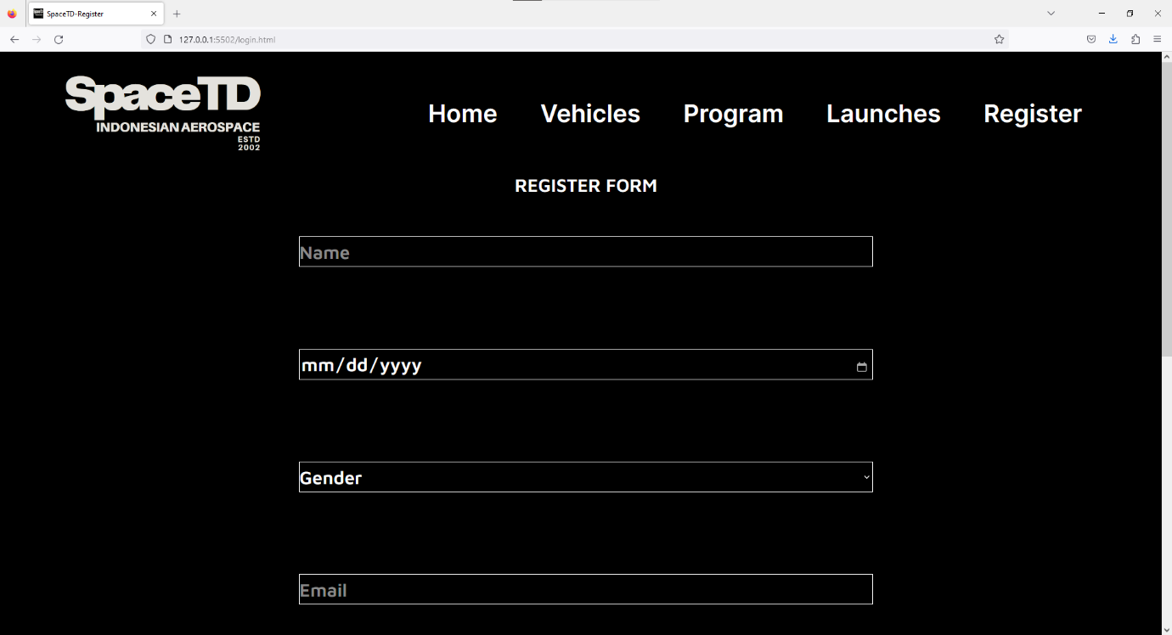Desktop View  
      
    The head of this page show the SpaceTD logo and title ‘SpaceTD-Register’. The page is also use black color as a background. The navigation bar is also same with Home Page. The body of this page contain Register title and form. The body provides a registration from for people who want to travel to space. The registration form requires the user to fill in all the input boxes that consist of at least 1 characters of name, a gender, a valid email address, date of birth, minimum 8 characters of password, and a nationality. Below the register form, there is register button. The footer of this page is the same as in the Home Page.
  + Tablet view  
    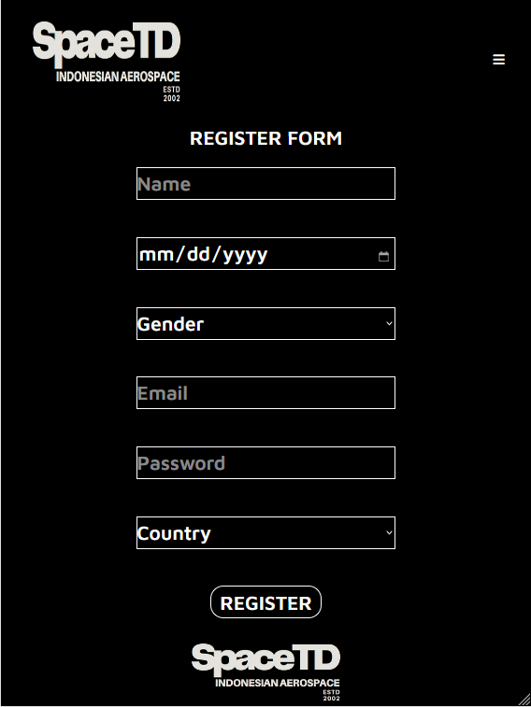  
    In the tablet view, the contents of the page are the same as in the desktop view. The differences are almost the same as in the tablet view of the Home Page.
  + Mobile phone view  
    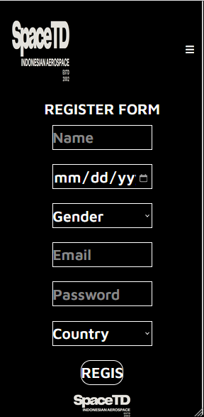  
    The mobile phone view same as the tablet view. The difference is the same as in the mobile phone view of the Home Page.
* Program
  + 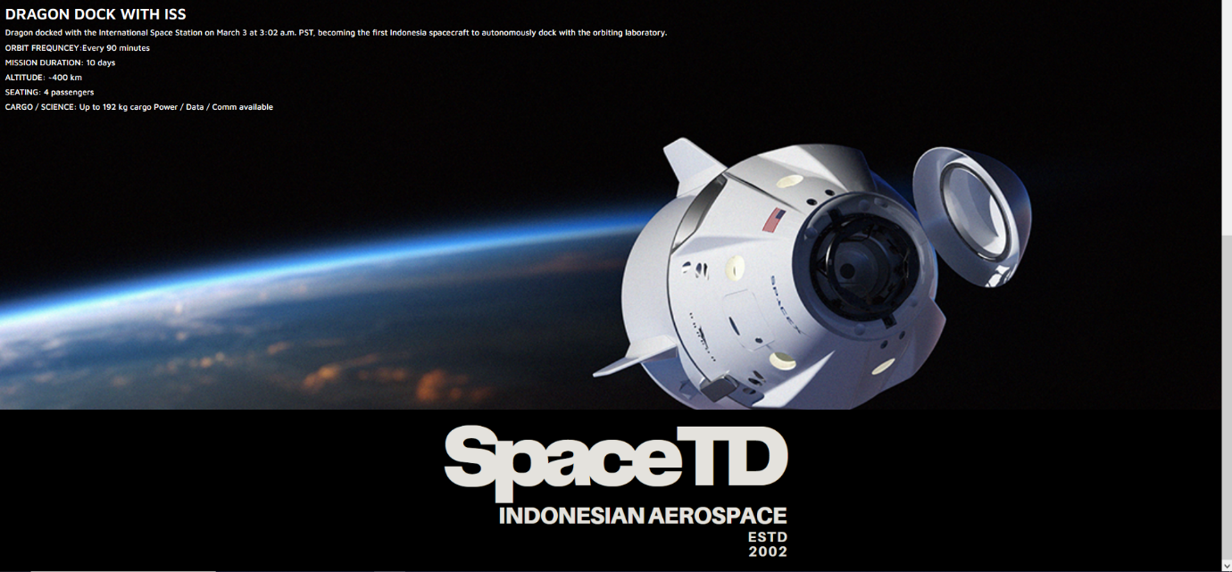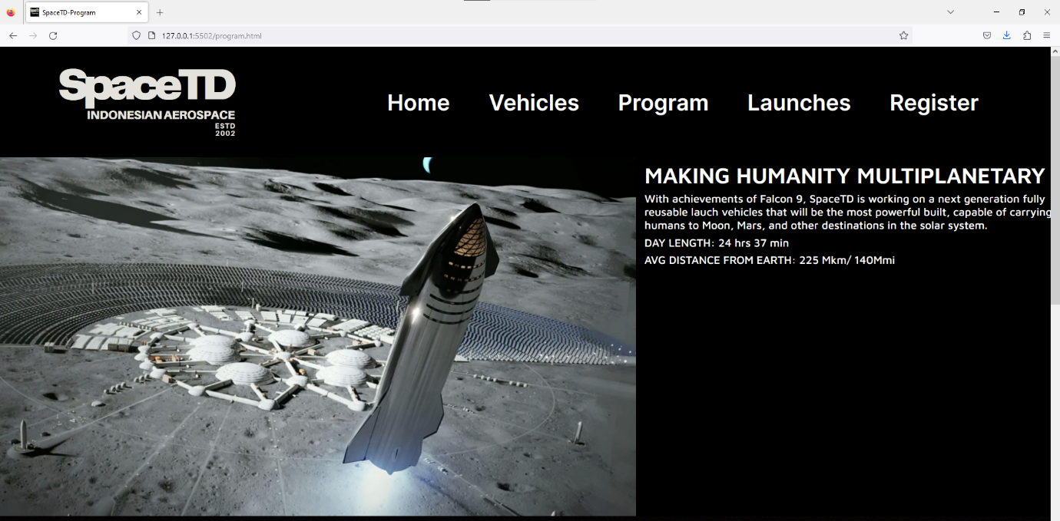Desktop View  
      
    The head of this page shows the SpaceTD logo and title ‘SpaceTD-Program’. Navigation bar is also same as Home Page Navigation bar. The body of this page is show list of SpaceTD space travel programs. The list contains the image of the programs, the programs’ name, and descriptions. The footer of this page is the same as in the Home Page.
  + Tablet View  
    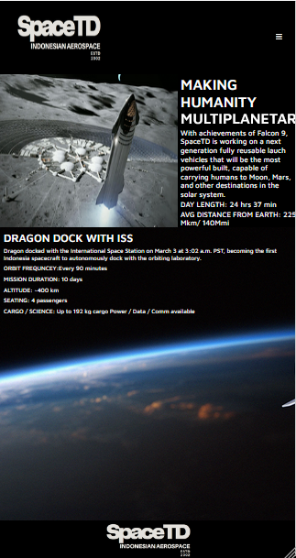  
    In tablet view is also same as desktop view. The difference is also same as tablet view home page.
  + Mobile phone view  
    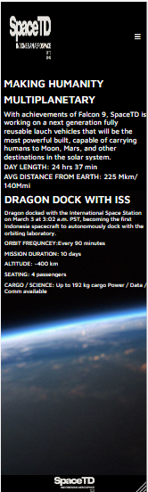  
    In the mobile phone view also same as tablet view, but the difference is the image of program is gone. The difference is also almost same as mobile phone view home page
* Launches Page
  + 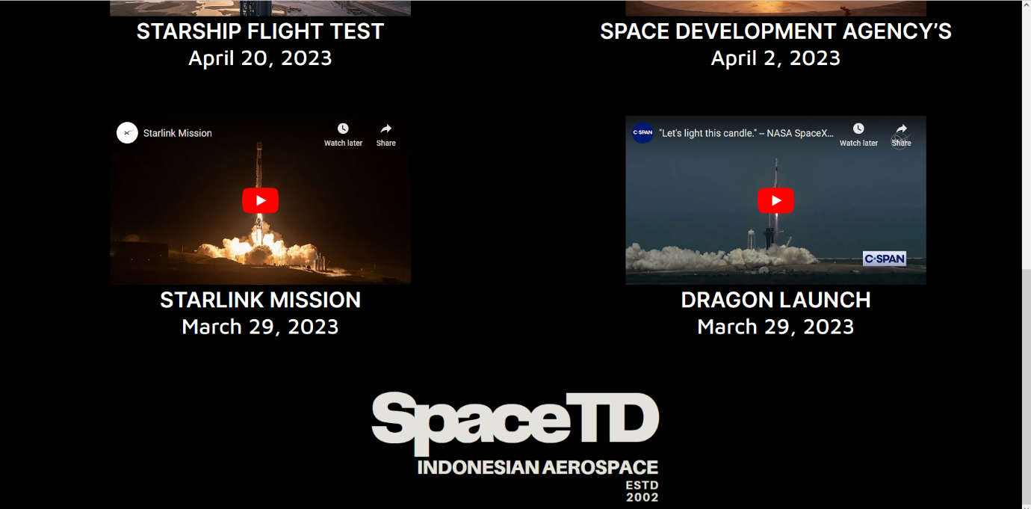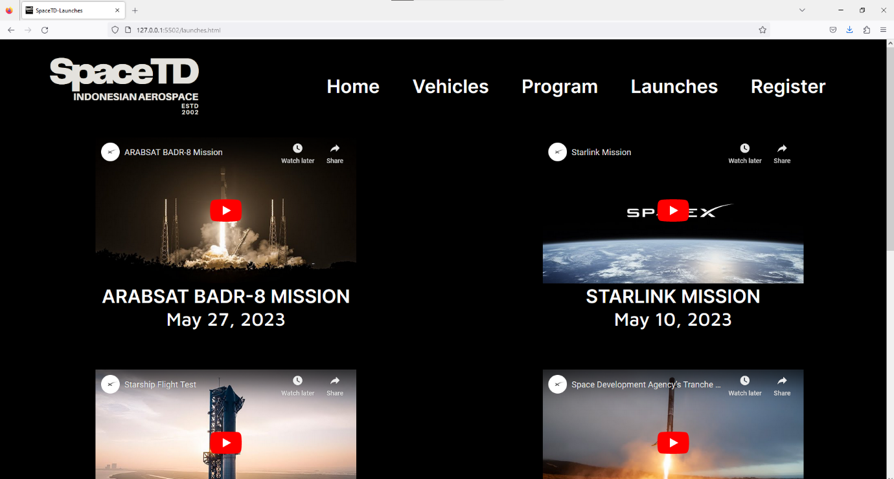Desktop view  
    The head of this page shows the SpaceTD logo and the page title ‘SpaceTD-Launches’. This page use black color background. The navigation bar is also same as home page navigation. The body of this page show all launch. The list contains the video of the rocket launches, missions’ name, and launch date. The footer of this page is also same as Home page footer.
  + Tablet View  
    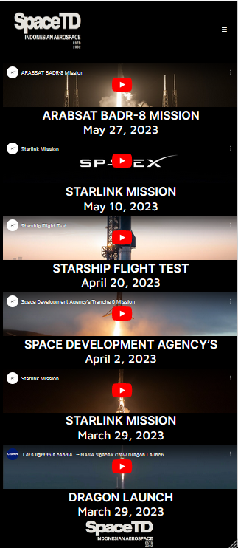  
    In the tablet view, the contents of the page are the same as in the desktop view. The difference is also same as tablet view home page.
  + Mobile phone view  
      
    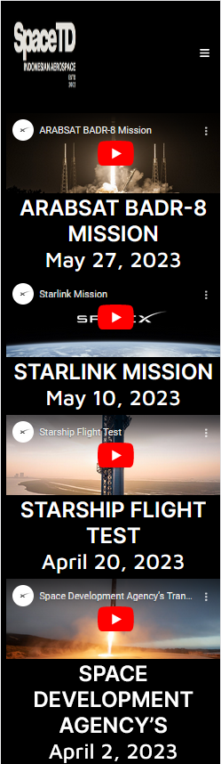

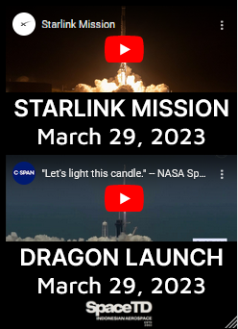  
  
In the mobile phone view is also same as home page view. The different is the same as in the mobile phone view of the home page.

Link:

1. Font-Family: Inter  
   <https://fonts.google.com/specimen/Inter>  
   Font-Family: Maven Pro  
   <https://fonts.google.com/specimen/Maven+Pro>
2. Navbar tonggle = ‘fa-solid fa-bars’, ‘fa-solid fa-xmark’  
   <https://cdnjs.cloudflare.com/ajax/libs/font-awesome/6.4.0/css/all.min.css>
3. Assets
   * <https://www.canva.com/design/DAFj2PpqsC4/CNG6TQtqF1S7wdiCweZ0VQ/edit?utm_content=DAFj2PpqsC4&utm_campaign=designshare&utm_medium=link2&utm_source=sharebutton> : SpaceTD Logo  
     https://wallpapercave.com/w/wp4568894: earth wallpaper
   * https://wallpapercave.com/w/wp6503939: dragon bc
   * https://wallpapercave.com/w/wp8807070: falcon 1 bc
   * https://uxwing.com/date-icon: date icon
   * https://sketchfab.com/3d-models/falcon-9-spacex-394f7cf52d124bbd9db69f24d1ff2f08: falcon9model
   * https://www.youtube.com/watch?v=dLQ2tZEH6G0: faclon 1 launch
   * https://sketchfab.com/3d-models/spacex-crew-dragon-b4189c6d1dad404a8ea25cad042161c1: dragonview
   * https://www.cgtrader.com/3d-models/space/spaceship/spacex-starship-heavy: starshipview
   * https://www.behance.net/gallery/77029515/SpaceX-Crew-Dragon-%284K-Wallpaper-FREE%29: dragondockiss
   * https://www.youtube.com/watch?v=1gmvUPTdoP4: dragonlaunchvid
   * https://www.youtube.com/watch?v=lBJ9uWdCLRI: ARABSAT BADR-8 Mission
   * https://www.youtube.com/watch?v=bzAcO60OPrk: starlink mission 11 may
   * https://www.youtube.com/watch?v=vnnUoZ66ihg&t=5s: Space Development Agency’s Tranche 0 Mission
   * https://www.youtube.com/watch?v=-1wcilQ58hI: starship flight test
   * https://www.youtube.com/watch?v=EfJxpU0CLNI: starlink mission
4. Website reference: <https://www.spacex.com/>   
   HTML element:
   1. Nationality list : https://gist.github.com/didats/8154290